SUMMER REVIEW : WHAT HAPPENED OVER THE SUMMER ?
1 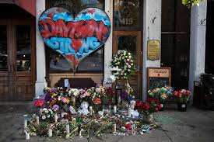 2 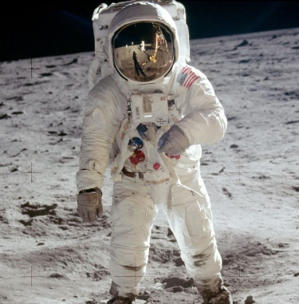3 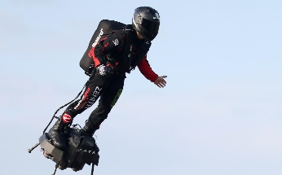4 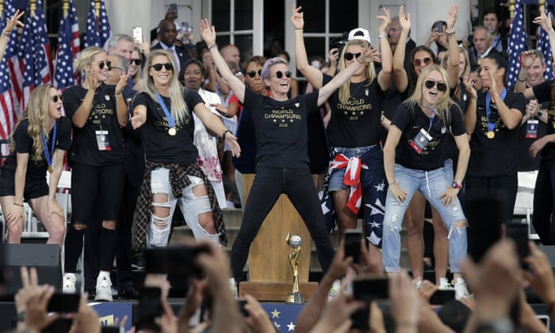
5 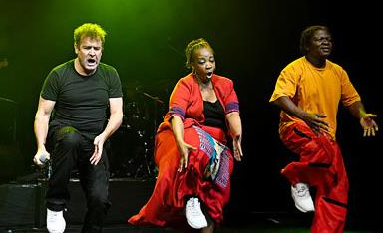6 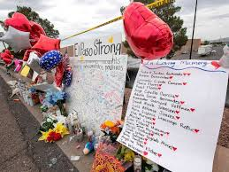 7 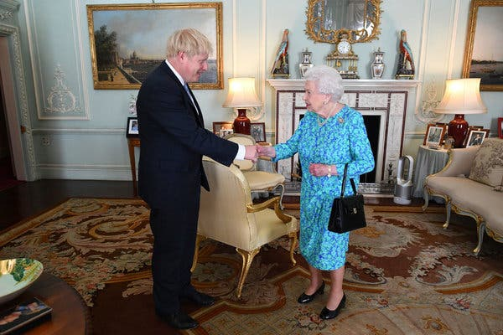
8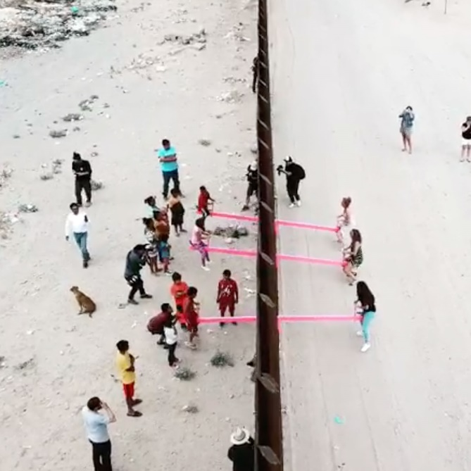 9 10 11 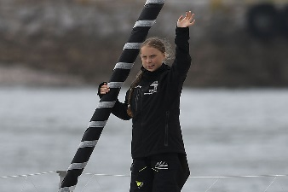
- For each definition, choose the corresponding picture above. Write the picture’s number in the grid below.

Picture n° | Event
 | July 10, The United States women’s national team, led by Megan Rapinoe, were celebrated with a parade in New York City two days after winning their fourth World Cup. The ceremony took place as the team’s push for pay equity with male players has gathered momentum. A few days before the finals, Rapinoe had declared she would not go to the White House if the team was invited.
 | July 16, : South African singer and songwriter Johnny Clegg, one of the few white artists to openly confront the apartheid government in the late 1970s and 1980s, died aged 66. His 1987 hit ‘Asimbonanga’, a tribute to Nelson Mandela, who at the time had been imprisoned on Robben Island for over two decades, was one of the high points of a glittering career.
 | July 21, The whole world celebrated the 50th Anniversary of the first Moon Landing. On 20 July 1969, the Eagle module from Apollo 11 landed at Tranquility Base. Hours later, Neil Armstrong made history by becoming the first person to step on the Moon. Armstrong was joined on the mission by his crewmates Buzz Aldrin and Michael Collins. Armstrong and Aldrin walked around for three hours.
 | July 24, : Former London Mayor Boris Johnson, who is the leader of the Conservative Party, replaced Theresa May as Prime Minister of the UK. He has pledged to deliver Brexit by the end of October 2019.
 | July 29 was Earth Overshoot Day. Every year, it marks the day when we (all of humanity) have used more from nature than our planet can renew in the entire year. According to the Global Footprint Network, Earth Overshoot Day has moved up the calendar by two months over the past 20 years.
 | July 30, A set of bright pink seesaws were installed between the United States and Mexico by two university professors. Photos and videos showed children and adults on both sides of the border playing on the seesaws. The US-Mexico border has become one of the defining features of Donald Trump’s presidency. His promise to “build a wall” between the two countries has yet to materialise but crowded migrant detention facilities, the use of teargas at the border and the separation of children from their parents are among some of the controversial tactics deployed by US authorities as its stance has become more hostile under the Trump administration.
 | August 4, French inventor Franky Zapata successfully crossed English Channel, riding on a jet-powered hoverboard he designed.
 | August 6, American novelist Toni Morrison died. She was noted for her examination of black experience (particularly black female experience) within the black community. She received the Nobel Prize for Literature in 1993. One of her most famous novels is Beloved, which is based on the true story of a runaway slave who, at the point of recapture, kills her infant daughter in order to spare her a life of slavery.
 | August 6, 22 people were killed in El Paso (TEXAS) after a mass shooting. Police said they found an anti-immigrant document espousing white nationalist and racist views, which they believe was written by the suspect. The 21-year old has been charged with capital murder, meaning he could face the death penalty.
 | August 6, A mass shooting in Dayton ,Oregon, left nine dead and at least 27 wounded. The shooter was killed by police.
 | August 14, Sixteen-year-old Greta Thunberg — who has long refused to fly due to carbon emissions — set sail aboard the "Malizia II," a no-comfort, high-tech, zero-emissions yacht to attend a New York "climate action" summit.

2-Look at the phonetic transcriptions and find in the
descriptions above the word it is related to.
3- Match each word with its phonetic transcription. What do you notice about the stress pattern ( = schema accentuel) ? Can you deduce the rule?
A)
[ˈmɪʃən] - - administration
[ədˌmɪnɪˈstreɪʃən] - - separation
[dɪˈtenʃən] - - mission
[sepəˈreɪʃən] - - examination
[ɪgˌzæmɪˈneɪʃən] - - detention
Règle d’accentuation:

B)
[kəˈmjuːnɪti] - - humanity
[ˈekwɪti] - - equity
[hjuːˈmænɪti] - -community
Règle d’accentuation:

[pəˈreɪd]
[ˈmeɪl]
[əˈpɑː^{r}thaɪt]
[ˈgʌvənmənt]
[kəˈrɪə^{r}]
[ˈhɪstrɪ]
['ɜːθ]
[ˈsiːsɔː]
[ˈbɪld]
[ˈkraʊdɪd]
[ˈprɒmɪs]
[ˈfeɪməs]
[ˈrɪtən]
[pəˈliːs]
[ˈklaɪmət]

4- Look at the following words: they all end in -ED. Classify them according to the pronunciation of the ending.
Designed-celebrated-walked-replaced-noted-pledged-decared-invited-based-wounded-received-killed
/d/ as in opened | /ɪd/ as in invented | /t/ as in walked

5- Oral comprehension: Choose one of the videos below to find out more about one of the events we talked about. Take notes to give as much information as possible to the rest of the class.
Video 1: How Greta Thunberg plans to cross the Atlantic Carbon-free. https://www.youtube.com/watch?v=9W7vX8BBnJ0
Video 2: Man Crosses the Channel on Hoverboard https://www.youtube.com/watch?v=HdBTe9RXJPc
Video 3: Team USA’s Rapinoe continues her ‘walking protest’ against Trump https://www.youtube.com/watch?v=ds8RqGa9Byo

